**VISVESVARAYA TECHNOLOGICAL UNIVERSITY**

**Jnana Sangama, Belagavi-590018**



**A**

**MINI PROJECT REPORT**

**“Online Examination Management System”** Submitted in partial fulfillment of the Bachelor Degree

**In**

**INFORMATION SCIENCE AND ENGINEERING**

**V SEMESTER DBMS LABORATORY WITH MINI PROJECT (18CSL58)**

**Submitted By**

**SAJITH UMAR 1HK20IS086**

**SYED HANNAN 1HK20IS104**

**SYEDA ZOBIA TAZEEN 1HK20IS111**

Under the guidance of

**Prof.SNEHA Prof.ANUSHA**

Assistant professor Assistant professor

**Department of Information Science and Engineering 2022-2023**



**Accredited by NAAC**

# HKBK COLLEGE OF ENGINEERING

**22/1, Nagawara, Bengaluru – 5600 045.**

**E-mail: info@hkbk.edu.in, URL:** [**www.hkbk.edu.in**](http://www.hkbk.edu.in/)

# **HKBK COLLEGE *of* ENGINEERING**



**Accredited by NAAC**

BENGALURU – 560 045

## DEPARTMENT OF INFORMATION SCIENCE AND ENGINEERING

**VISVESVARAYA TECHNLOGICAL UNIVERSITY**

A

**MINI PROJECT REPORT ON**

**“Online Examination Management System”**

Submitted in partial fulfillment of the project in

**V Semester, DBMS LABORATORY WITH MINI PROJECT (18CSL58)**

**2022-23**

**SUBMITTED BY:**

|  |  |
| --- | --- |
| **SAJITH UMAR 1HK20IS086** **SYED HANNAN 1HK20IS104**  **SYEDA ZOBIA TAZEEN 1HK20IS111** |  |

# HKBK COLLEGE OF ENGINEERING



**Accredited by NAAC**

**DEPARTMENT OF INFORMATION SCIENCE AND ENGINEERING**

## CERTIFICATE

Certified that the mini project entitled **“Online Examination Management System”** is a bonafide wordcarrieout by **SAJITH UMAR (1HK20IS086) ,SYED HANNAN B(1HK20IS104) SYEDA ZOBIA TAZEEN(1HK20IS111)** and in partial fulfillment for the award of Degree of Bachelor of Engineering in **Information Science and Engineering** of the Visvesvaraya Technological University, Belagavi during the year 2020-21. It is certified that all corrections/suggestions indicated for the Internal Assessment have been incorporated in the mini project report deposited in the departmental library. The mini project report has been approved as it satisfies the academic requirements in respect of **DBMS Laboratory with Mini Project (18CSL58)** prescribed for the Bachelor of Engineering Degree.

Guide & Co- guide Principa HOD

(Prof.Sneha) (Prof.Tabassum Ara) (Dr. A Syed Mustafa)

(Prof.Anusha)

Name of Examiners Signature with date

1.

2.

**ACKNOWLEDGEMENT**

We would like to place our regards and acknowledgement to all who helped in making this project possible. There are many people who worked behind the screen to help make it possible the below listed are a few of them.

First of all, we would take this opportunity to express our heartfelt gratitude to **Mr. C.M. Ibrahim,** Chairman, **Mr. C.M. Faiz Mohammed,** Director and **Prof.Tabssum Ara,** Principal for all the infrastructure provided to complete the project in time.

We are deeply indebted to **Dr. A. Syed Mustafa,** HOD, Information Science and Engineering for the ineffable encouragement he provided in successful completion of the project.

We sincerely thank our guide, **Prof. Sneha** and Co-guide, **Prof.Anusha**, Assistant Professor for their constant assistance, support, patience, endurance and constructive suggestions for the betterment of the project.

We are extremely thankful to the teaching and non-teaching staff of the **Department of Information Science and Engineering** for their valuable guidance and cooperation throughout our dissertation.

**SAJITH UMAR (1HK20IS086)**

**SYED HANNAN (1HK20IS104)**

**SYEDA ZOBIA TAZEEN (1HK20IS111)**

**ABSTRACT**

Online examination system is a web-based examination system where examination are given online, either through the internet or intranet using computer system. The main goal of this on an examination system is to effectively evaluate the students thoroughly through a totally automated system that not only reduce the required time but also obtain fast and accurate results. It allows a particular company or Institute to arrange conduct and manage examinations via and online environment this can be done through the internet internet and Local area network environments.Some of the problems faced by the manual examination system are delay in result processing filling posses problem filtering of records is not easy the chance of loss of records is high and also record searching is difficult maintenance of the system is also very difficult and takes a lot of time and effort. I intent to use the system development life cycle which is conceptual model used in project management that describe the stages involved in an information system development project.

**TABLE OF CONTENTS**

**ACKNOWLEDGEMENT .................................................................................................... III**

**ABSTRACT ........................................................................................................................... IV**

**TABLE OF CONTENTS ...................................................................................................... V**

**=LIST OF FIGURES .............................................................................................................. VI**

**=LIST OF TABLES .............................................................................................................. VII**

**CHAPTER 1 INTRODUCTION ........................................................................................... 2**

1.1 Overview .................................................................................................................... 2

1.2 Content and Organization of the Report .................................................................... 2

1.3 Objective .................................................................................................................... 2

**CHAPTER 2 REQUIREMENT SPECIFICATION............................................................ 5**

2.1 Functional Requirements............................................................................................ 5 2.2 Non Functional Requirements .................................................................................... 5

2.3 Software Requirements .............................................................................................. 5

**CHAPTER 3 DESIGN ............................................................................................................ 8**

3.1 High Level Design ..................................................................................................... 8

3.2 Flow Chart .................................................................................................................. 8

**CHAPTER 4 IMPLEMENTATION ................................................................................... 11**

4.1 Libraries Used .......................................................................................................... 11

4.2 Explanation of Functions ......................................................................................... 11

4.3 User Defined Functions ............................................................................................ 11

**CHAPTER 5 SNAPSHOTS ................................................................................................. 14**

**CONCLUSION............................................................................ 18**

**REFERENCES ...................................................................................................................... 19**

## CHAPTER -1 INTRODUCTION

**Chapter 1**

**INTRODUCTION**

The purpose of Hospital Management System is to automate the existingmanual system by the help of computerized equipment’s and fully fledgedcomputer software, full filling their requirements so that their valuable datacan be stored for a longer period with easy accessing and manipulationof the same. The required software and hardware are easily availableand easy to work with.

* **Objective**

Hospital Management System described above, can lead to error free, secure, reliable and fast management system. it can assist the user to concentrate on their activities rather to concentrate on their record keeping thus helping the organization in better utilization of resources. The organization can maintain records without redundant entries

**1.2 Constraints**

* + 1. **User interface Constraints**

Using this system is fairly simple and intuitive. A user familiar with basic browser navigation skills should be able to understand all functionality provided by the system.

* + 1. **Hardware Constraints**

Database is maintained on the database server in a secure way. The system should work on most home desktop and laptop computers which support PHP and MySQL.

* **.3 Software Constraints**

The system will be intended to run on Firefox 4 and above, Google Chrome 10 and above and Internet Explorer 8 and above.

## CHAPTER -2 REQUIREMENT SPECIFICATION

**Chapter 2**

### REQUIREMENT SPECIFICATION

* **Functional Requirements**

In software engineering, a functional requirement defines a system or its component. It describes the functions a software must perform. A function is nothing but inputs, its behavior, and outputs. It can be a calculation, data manipulation, business process, user interaction, or any other specific functionality which defines what function a system is likely to perform. Functional Requirements are also called Functional Specification.

* **Non-Functional Requirements**

In systems engineering and requirements engineering, a non-functional requirement (NFR) is a requirement that specifies criteria that can be used to judge the operation of a system, rather than specific behaviors. They are contrasted with functional requirements that define specific behavior or functions. The plan for implementing functional requirements is detailed in the system design. The plan for implementing non-functional requirements is detailed in the system architecture, because they are usually architecturally significant requirements.

* **Software Requirements** Front End: HTML, CSS, PHP

Back End: SQL

Database: MySQL SERVER 2008 or higher

The following operating systems are officially supported:

* Windows 7 (64-bit, Professional level or higher)
* Mac OS X 10.5.1+
* Ubuntu 9.10 (64bit)
* Ubuntu 8.04 (32bit/64bit)

**Hardware Requirements**

* CPU: Intel Core or Xeon 3GHz (or Dual Core 2GHz)
* Cores: Single (Dual/Quad Core is recommended)
* RAM: 4 GB (6 GB recommended)
* Graphic Accelerators: NVidia or ATI with support of OpenGL 1.5 or higher.
* Display Resolution: 1280×1024 is recommended, 1024×768 is minimum

**2.5 Introduction to EnvironmentWhy PHP?**

Most important advantage of PHP is that it’s open source and free from cost. It can be downloaded at anywhere and readily available to use for event of web applications.

It is platform independent. PHP based applications can run on any OS like UNIX, Linux and Windows, etc.

Application can easily be loaded which are based on PHP and connected to database. It’s mainly used due to its faster rate of loading over slow internet speed than another programming language.

It has less learning curve, because it is simple and straightforward to use. Someone familiar with C programming can easily work on PHP.

It is more stable from a few years with assistance of providing continuous support to various versions.

### Advantages of DBMS

* Data independence: In DBMS, you can easily change the structure of database without modifying the application program.
* Integration of data: In DBMS, data in database is stored in tables. A single database contains multiple tables and relationships can be created between tables.
* Data Consistency: By controlling the data redundancy, the data consistency is obtained. If a data item appears only once, any update to its value has to be performed only once and the updated value is immediately available to all users.
* Sharing of data: In DBMS, data can be shared by authorized users of the organization. Many users can be authorized to access the same piece of information simultaneously.

## CHAPTER -3 DESIGN

**Chapter 3**

**DESIGN**

### • System Architecture • ER Diagram

This ER diagram represents the model of Hospital Management System. The entityrelationship diagram of shows all the visual instruments of database tables and relationship between Patient, Doctor, Receptionist etc. It uses structured data and defines the relationship between structured data groups of Hospital Management System functionalities. The main entities of Hospital Management are Patient, Doctor, Receptionist, Prescription.

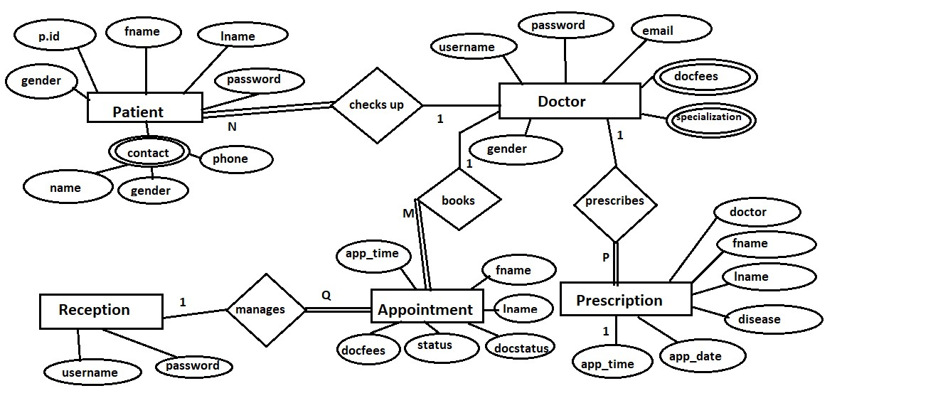

**3.3 Schema Diagram**

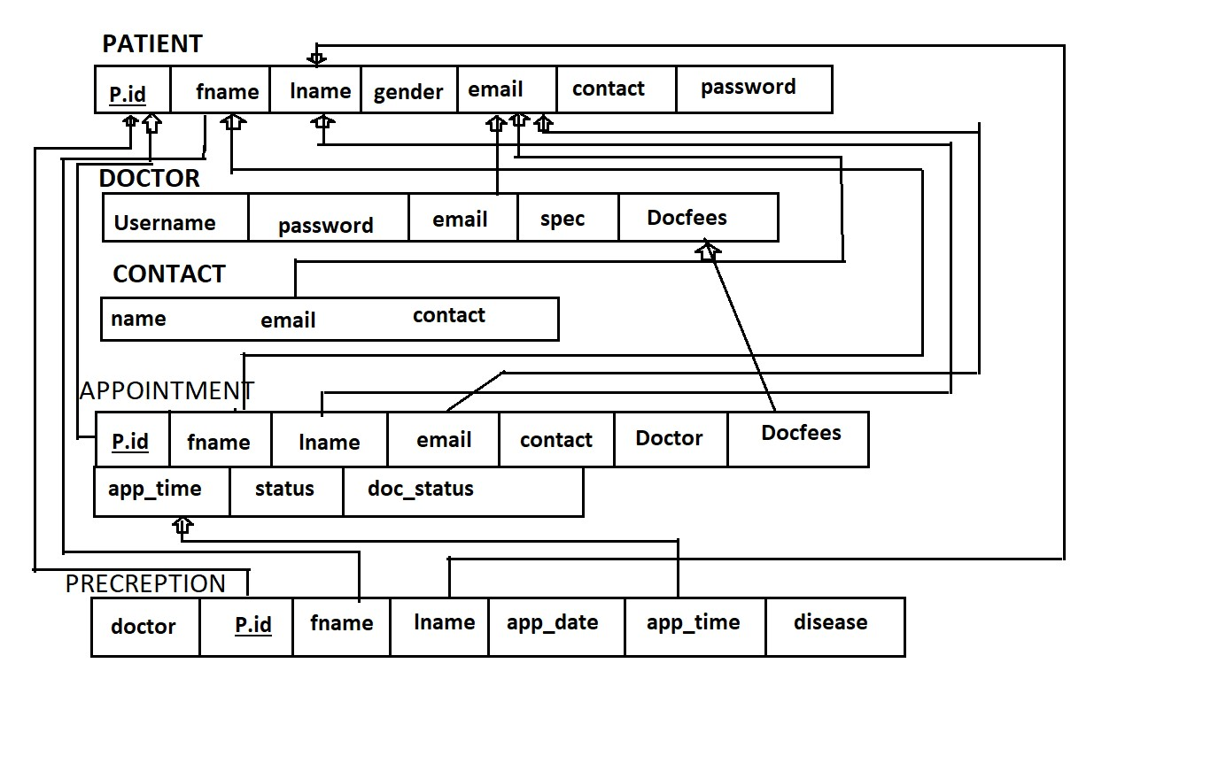

**Receptionist Entity:**

|  |  |
| --- | --- |
| **Attribute Name** | **Value** |
| **Username** | varchar(50) |
| **Password** | varchar(30) |

**Appointments Entity:**

|  |  |
| --- | --- |
| **Attribute Name** | **Value** |
| Patient Id | int(11) |
| ID | int(11) |
| FName | varchar(20) |
| Lname | varchar(20) |
| Gender | varchar(10) |
| Email | varchar(30) |
| Contact | varchar(10) |
| Docfees | int(5) |
| Appdate | date |
| AppTime | time |
| Userstatus | int(5) |
| Doctorstatus | int(5) |
| Doctor | varchar(30) |

**Contact Entity:**

|  |  |
| --- | --- |
| **Attribute Name** | **Value** |
| **Name** | varchar(30) |
| Email | text |
| Contact | varchar(10) |
| Message | varchar(200) |

**Doctor Entity:**

|  |  |
| --- | --- |
| **Attribute Name** | **Value** |
| Username | varchar(50) |
| Password | varchar(50) |
| Email | varchar(50) |
| Spec | varchar(50) |
| Docfees | int(10) |

**Patient Entity:**

|  |  |
| --- | --- |
| **Attribute Name** | **Value** |
| Pid | int(11) |
| Fname | varchar(20) |
| Lname | varchar(20) |
| Gender | varchar(10) |
| Email | varchar(30) |
| Contact | varchar(10) |
| Password | varchar(30) |
| Cpassword | varchar(30) |

**Prescription Entity:**

|  |  |
| --- | --- |
| **Attribute Name** | **Value** |
| **Doctor** | varchar(50) |
| **Pid** | int(11) |
| **ID** | int(11) |
| **Fname** | varchar(50) |
| **Lname** | varchar(50) |
| **Appdate** | date |
| **Apptime** | time |
| **Disease** | varchar(250) |
| **Allergy** | varchar(250) |
| **Prescription** | varchar(1000) |

## CHAPTER -4

**IMPLEMENTATION**

**Chapter 4**

**IMPLEMENTATION**

* **Constraints in Relational Schema:**

|  |  |  |
| --- | --- | --- |
| **Entity** | **Primary key** | **Foreign Key** |
| **Receptionist** | _ | _ |
| **Appointment** | Pid | Contact,Email |
| **Doctor** | Email | Contact |
| **Prescription** | Pid | _ |
| **Patient** | Pid | _ |
| **Contact** | Contact | _ |

* **Source Code**

**Admin Panel PHP:**<!DOCTYPE html>

<?php include('func.php'); include('newfunc.php');

$con=mysqli_connect("localhost","root","","myhmsdb");

$pid = $_SESSION['pid'];

$username = $_SESSION['username'];

|  |  |  |
| --- | --- | --- |
| **Hospital Management System**  $email = $_SESSION['email'];  $fname = $_SESSION['fname'];  $gender = $_SESSION['gender'];  $lname = $_SESSION['lname'];  $contact = $_SESSION['contact'];          if(isset($_POST['app-submit']))  {  $pid = $_SESSION['pid'];  $username = $_SESSION['username'];  $email = $_SESSION['email'];  $fname = $_SESSION['fname'];  $lname = $_SESSION['lname'];  $gender = $_SESSION['gender'];  $contact = $_SESSION['contact'];  $doctor=$_POST['doctor'];  $email=$_SESSION['email'];  # $fees=$_POST['fees'];  $docFees=$_POST['docFees'];      $appdate=$_POST['appdate'];  $apptime=$_POST['apptime']; $cur_date = date("Y-m-d"); date_default_timezone_set('Asia/Kolkata');  $cur_time = date("H:i:s");  $apptime1 = strtotime($apptime);  $appdate1 = strtotime($appdate);  if(date("Y-m-d",$appdate1)>=$cur_date){  Department Of ISE,HKBK | 16 | 2021-22 |

if((date("Y-m-d",$appdate1)==$cur_date and date("H:i:s",$apptime1)>$cur_time) or date("Y-md",$appdate1)>$cur_date) {

$check_query = mysqli_query($con,"select apptime from appointmenttb where doctor='$doctor' and appdate='$appdate' and apptime='$apptime'");

if(mysqli_num_rows($check_query)==0){

$query=mysqli_query($con,"insert into

appointmenttb(pid,fname,lname,gender,email,contact,doctor,docFees,appdate,apptime,userStatus,doctorSt atus)

values($pid,'$fname','$lname','$gender','$email','$contact','$doctor','$docFees','$appdate','$apptime','1','1')")

;

if($query)

{

echo "<script>alert('Your appointment successfully booked');</script>";

} else{

echo "<script>alert('Unable to process your request. Please try again!');</script>";

} } else{

echo "<script>alert('We are sorry to inform that the doctor is not available in this time or date. Please choose different time or date!');</script>";

} } else{

echo "<script>alert('Select a time or date in the future!');</script>";

} } else{

echo "<script>alert('Select a time or date in the future!');</script>"; }

}

if(isset($_GET['cancel']))

{

$query=mysqli_query($con,"update appointmenttb set userStatus='0' where ID = '".$_GET['ID']."'"); if($query)

{

echo "<script>alert('Your appointment successfully cancelled');</script>";

}

}

function generate_bill(){

$con=mysqli_connect("localhost","root","","myhmsdb");

$pid = $_SESSION['pid'];

$output='';

$query=mysqli_query($con,"select

p.pid,p.ID,p.fname,p.lname,p.doctor,p.appdate,p.apptime,p.disease,p.allergy,p.prescription,a.docFees from prestb p inner join appointmenttb a on p.ID=a.ID and p.pid = '$pid' and p.ID = '".$_GET['ID']."'"); while($row = mysqli_fetch_array($query)){

$output .= '

<label> Patient ID : </label>'.$row["pid"].'<br/><br/>

<label> Appointment ID : </label>'.$row["ID"].'<br/><br/>

<label> Patient Name : </label>'.$row["fname"].' '.$row["lname"].'<br/><br/>

<label> Doctor Name : </label>'.$row["doctor"].'<br/><br/>

<label> Appointment Date : </label>'.$row["appdate"].'<br/><br/>

<label> Appointment Time : </label>'.$row["apptime"].'<br/><br/>

<label> Disease : </label>'.$row["disease"].'<br/><br/>

<label> Allergies : </label>'.$row["allergy"].'<br/><br/>

<label> Prescription : </label>'.$row["prescription"].'<br/><br/>

<label> Fees Paid : </label>'.$row["docFees"].'<br/>

'; }

return $output;

} if(isset($_GET["generate_bill"])){ require_once("TCPDF/tcpdf.php");

$obj_pdf = new TCPDF('P',PDF_UNIT,PDF_PAGE_FORMAT,true,'UTF-8',false);

$obj_pdf -> SetCreator(PDF_CREATOR);

$obj_pdf -> SetTitle("Generate Bill");

$obj_pdf -> SetHeaderData('','',PDF_HEADER_TITLE,PDF_HEADER_STRING);

$obj_pdf -> SetHeaderFont(Array(PDF_FONT_NAME_MAIN,'',PDF_FONT_SIZE_MAIN));

$obj_pdf -> SetFooterFont(Array(PDF_FONT_NAME_MAIN,'',PDF_FONT_SIZE_MAIN));

$obj_pdf -> SetDefaultMonospacedFont('helvetica');

$obj_pdf -> SetFooterMargin(PDF_MARGIN_FOOTER);

$obj_pdf -> SetMargins(PDF_MARGIN_LEFT,'5',PDF_MARGIN_RIGHT);

$obj_pdf -> SetPrintHeader(false);

$obj_pdf -> SetPrintFooter(false);

$obj_pdf -> SetAutoPageBreak(TRUE, 10);

$obj_pdf -> SetFont('helvetica','',12);

$obj_pdf -> AddPage();

$content = '';

$content .= '

<br/>

<h2 align ="center"> Global Hospitals</h2></br>

<h3 align ="center"> Bill</h3> ';

$content .= generate_bill(); $obj_pdf -> writeHTML($content); ob_end_clean();

$obj_pdf -> Output("bill.pdf",'I');

} function get_specs(){

$con=mysqli_connect("localhost","root","","myhmsdb");

$query=mysqli_query($con,"select username,spec from doctb");

$docarray = array();

while($row =mysqli_fetch_assoc($query))

{

$docarray[] = $row;

}

return json_encode($docarray);

}

?>

<html lang="en">

<head>

<!-- Required meta tags -->

<meta charset="utf-8">

<link rel="shortcut icon" type="image/x-icon" href="images/favicon.png" />

<meta name="viewport" content="width=device-width, initial-scale=1, shrink-to-fit=no">

<link rel="stylesheet" type="text/css" href="font-awesome-4.7.0/css/font-awesome.min.css">

<link rel="stylesheet" href="style.css">

<!-- Bootstrap CSS -->

<link rel="stylesheet" href="vendor/fontawesome/css/font-awesome.min.css"

<link rel="stylesheet" href="https://maxcdn.bootstrapcdn.com/bootstrap/4.0.0beta/css/bootstrap.min.css" integrity="sha384-

/Y6pD6FV/Vv2HJnA6t+vslU6fwYXjCFtcEpHbNJ0lyAFsXTsjBbfaDjzALeQsN6M" crossorigin="anonymous">

<link rel="stylesheet" href="https://stackpath.bootstrapcdn.com/bootstrap/4.3.1/css/bootstrap.min.css" integrity="sha384-

ggOyR0iXCbMQv3Xipma34MD+dH/1fQ784/j6cY/iJTQUOhcWr7x9JvoRxT2MZw1T" crossorigin="anonymous">

<link href="https://fonts.googleapis.com/css?family=IBM+Plex+Sans&display=swap" rel="stylesheet">

<nav class="navbar navbar-expand-lg navbar-dark bg-primary fixed-top">

<a class="navbar-brand" href="#"><i class="fa fa-user-plus" aria-hidden="true"></i> Global Hospital </a>

<button class="navbar-toggler" type="button" data-toggle="collapse" data-

target="#navbarSupportedContent" aria-controls="navbarSupportedContent" aria-expanded="false" arialabel="Toggle navigation">

<span class="navbar-toggler-icon"></span>

</button>

<style > .bg-primary {

background: -webkit-linear-gradient(left, #3931af, #00c6ff);

}

.list-group-item.active { z-index: 2; color: #fff;

background-color: #342ac1; border-color: #007bff;

}

.text-primary { color: #342ac1!important;

}

.btn-primary{

background-color: #3c50c1; border-color: #3c50c1;

}

</style>

<div class="collapse navbar-collapse" id="navbarSupportedContent">

<ul class="navbar-nav mr-auto">

<li class="nav-item">

<a class="nav-link" href="logout.php"><i class="fa fa-sign-out" aria-hidden="true"></i>Logout</a>

</li>

<li class="nav-item">

<a class="nav-link" href="#"></a>

</li>

</ul>

</div>

</nav>

</head>

<style type="text/css">

button:hover{cursor:pointer;}

#inputbtn:hover{cursor:pointer;}

</style>

<body style="padding-top:50px;">

<div class="container-fluid" style="margin-top:50px;">

<h3 style = "margin-left: 40%; padding-bottom: 20px; font-family: 'IBM Plex Sans', sans-serif;"> Welcome &nbsp<?php echo $username ?>

</h3>

<div class="row">

<div class="col-md-4" style="max-width:25%; margin-top: 3%">

<div class="list-group" id="list-tab" role="tablist">

<a class="list-group-item list-group-item-action active" id="list-dash-list" data-toggle="list" href="#list-dash" role="tab" aria-controls="home">Dashboard</a>

<a class="list-group-item list-group-item-action" id="list-home-list" data-toggle="list" href="#listhome" role="tab" aria-controls="home">Book Appointment</a>

<a class="list-group-item list-group-item-action" href="#app-hist" id="list-pat-list" role="tab" datatoggle="list" aria-controls="home">Appointment History</a>

<a class="list-group-item list-group-item-action" href="#list-pres" id="list-pres-list" role="tab" datatoggle="list" aria-controls="home">Prescriptions</a>

</div><br>

</div>

<div class="col-md-8" style="margin-top: 3%;">

<div class="tab-content" id="nav-tabContent" style="width: 950px;">

<div class="tab-pane fade show active" id="list-dash" role="tabpanel" aria-labelledby="list-dash-list">

<div class="container-fluid container-fullw bg-white" >

<div class="row">

<div class="col-sm-4" style="left: 5%">

<div class="panel panel-white no-radius text-center">

<div class="panel-body">

<span class="fa-stack fa-2x"> <i class="fa fa-square fa-stack-2x text-primary"></i> <i class="fa fa-terminal fa-stack-1x fa-inverse"></i> </span>

<h4 class="StepTitle" style="margin-top: 5%;"> Book My Appointment</h4>

<script>

function clickDiv(id) {

document.querySelector(id).click();

}

</script>

<p class="links cl-effect-1">

<a href="#list-home" onclick="clickDiv('#list-home-list')">

Book Appointment

</a>

</p>

</div>

</div>

</div>

<div class="col-sm-4" style="left: 10%">

<div class="panel panel-white no-radius text-center">

<div class="panel-body" >

<span class="fa-stack fa-2x"> <i class="fa fa-square fa-stack-2x text-primary"></i> <i class="fa fa-paperclip fa-stack-1x fa-inverse"></i> </span>

<h4 class="StepTitle" style="margin-top: 5%;">My Appointments</h2>

<p class="cl-effect-1">

<a href="#app-hist" onclick="clickDiv('#list-pat-list')">

View Appointment History

</a>

</p>

</div>

</div>

</div>

</div>

<div class="col-sm-4" style="left: 20%;margin-top:5%">

<div class="panel panel-white no-radius text-center"> <div class="panel-body" >

<span class="fa-stack fa-2x"> <i class="fa fa-square fa-stack-2x textprimary"></i> <i class="fa fa-list-ul fa-stack-1x fa-inverse"></i> </span>

<h4 class="StepTitle" style="margin-top: 5%;">Prescriptions</h2>

<p class="cl-effect-1">

<a href="#list-pres" onclick="clickDiv('#list-pres-list')">

View Prescription List

</a>

</p>

</div>

</div>

</div>

</div>

</div>

<div class="tab-pane fade" id="list-home" role="tabpanel" aria-labelledby="list-home-list">

<div class="container-fluid">

<div class="card">

<div class="card-body">

<center><h4>Create an appointment</h4></center><br>

<form class="form-group" method="post" action="admin-panel.php">

<div class="row">

<!-- <?php

$con=mysqli_connect("localhost","root","","myhmsdb");

$query=mysqli_query($con,"select username,spec from doctb");

$docarray = array();

while($row =mysqli_fetch_assoc($query))

{

$docarray[] = $row;

}

echo json_encode($docarray);

?>

<div class="col-md-4">

<label for="spec">Specialization:</label>

|  |  |
| --- | --- |
| **Hospital Management System**  </div>  <div class="col-md-8">  <select name="spec" class="form-control" id="spec">  <option value="" disabled selected>Select Specialization</option>  <?php  display_specs();  ?>  </select>  </div>  <br><br>  <script>  document.getElementById('spec').onchange = function foo() { let spec = this.value; console.log(spec)  let docs = [...document.getElementById('doctor').options];    docs.forEach((el, ind, arr)=>{ arr[ind].setAttribute("style","");  if (el.getAttribute("data-spec") != spec ) { arr[ind].setAttribute("style","display: none");  }  });  };  </script>  <div class="col-md-4"><label for="doctor">Doctors:</label></div>  <div class="col-md-8">  <select name="doctor" class="form-control" id="doctor" required="required">  <option value="" disabled selected>Select Doctor</option>  <?php display_docs(); ?>  </select>  </div><br/><br/>  Department Of ISE,HKBK 25 | 2021-22 |

<script>

document.getElementById('doctor').onchange = function updateFees(e) {

var selection = document.querySelector(`[value=${this.value}]`).getAttribute('data-value'); document.getElementById('docFees').value = selection;

};

</script>

<!-- <div class="col-md-4"><label for="doctor">Doctors:</label></div>

<div class="col-md-8">

<select name="doctor" class="form-control" id="doctor1" required="required">

<option value="" disabled selected>Select Doctor</option>

</select>

</div>

<br><br> -->

<!-- <script>

document.getElementById("spec").onchange = function updateSpecs(event) { var selected = document.querySelector(`[datavalue=${this.value}]`).getAttribute("value");

console.log(selected);

var options = document.getElementById("doctor1").querySelectorAll("option"); for (i = 0; i < options.length; i++) { var currentOption = options[i];

var category = options[i].getAttribute("data-spec"); if (category == selected) {

currentOption.style.display = "block";

} else {

currentOption.style.display = "none";

}

}

}

</script> -->

|  |  |
| --- | --- |
| **Hospital Management System**      <!-- <script> let data =    document.getElementById('spec').onchange = function updateSpecs(e) { let values = data.filter(obj => obj.spec == this.value).map(o => o.username); document.getElementById('doctor1').value =  document.querySelector(`[value=${values}]`).getAttribute('data-value');  };  </script> -->  <div class="col-md-4"><label for="consultancyfees">  Consultancy Fees  </label></div>  <div class="col-md-8">  <!-- <div id="docFees">Select a doctor</div> -->  <input class="form-control" type="text" name="docFees" id="docFees" readonly="readonly"/>  </div><br><br>  <div class="col-md-4"><label>Appointment Date</label></div>  <div class="col-md-8"><input type="date" class="form-control datepicker" name="appdate"></div><br><br>  <div class="col-md-4"><label>Appointment Time</label></div>  <div class="col-md-8">  <!-- <input type="time" class="form-control" name="apptime"> -->  <select name="apptime" class="form-control" id="apptime" required="required">  <option value="" disabled selected>Select Time</option>  <option value="08:00:00">8:00 AM</option>  <option value="10:00:00">10:00 AM</option>  <option value="12:00:00">12:00 PM</option>  <option value="14:00:00">2:00 PM</option> <option value="16:00:00">4:00 PM</option>  </select>  </div><br><br>  Department Of ISE,HKBK 27 | 2021-22 |

<div class="col-md-4">

<input type="submit" name="app-submit" value="Create new entry" class="btn btn-primary" id="inputbtn">

</div>

<div class="col-md-8"></div>

</div>

</form>

</div>

</div>

</div><br>

</div>

<div class="tab-pane fade" id="app-hist" role="tabpanel" aria-labelledby="list-pat-list">

<table class="table table-hover">

<thead>

<tr>

<th scope="col">Doctor Name</th>

<th scope="col">Consultancy Fees</th>

<th scope="col">Appointment Date</th>

<th scope="col">Appointment Time</th>

<th scope="col">Current Status</th>

<th scope="col">Action</th>

</tr>

</thead>

<tbody>

<?php

$con=mysqli_connect("localhost","root","","myhmsdb"); global $con;

$query = "select ID,doctor,docFees,appdate,apptime,userStatus,doctorStatus from appointmenttb where fname ='$fname' and lname='$lname';";

$result = mysqli_query($con,$query); while ($row = mysqli_fetch_array($result)){

#$fname = $row['fname'];

#$lname = $row['lname'];

#$email = $row['email'];

#$contact = $row['contact'];

?>

<tr>

<td><?php echo $row['doctor'];?></td>

<td><?php echo $row['docFees'];?></td>

<td><?php echo $row['appdate'];?></td>

<td><?php echo $row['apptime'];?></td>

<td>

<?php if(($row['userStatus']==1) && ($row['doctorStatus']==1))

{

echo "Active";

}

if(($row['userStatus']==0) && ($row['doctorStatus']==1))

{

echo "Cancelled by You";

}

if(($row['userStatus']==1) && ($row['doctorStatus']==0))

{

echo "Cancelled by Doctor";

}

?></td>

<td>

<?php if(($row['userStatus']==1) && ($row['doctorStatus']==1))

{ ?>

<a href="admin-panel.php?ID=<?php echo $row['ID']?>&cancel=update" onClick="return confirm('Are you sure you want to cancel this appointment ?')" title="Cancel Appointment" tooltip-placement="top" tooltip="Remove"><button class="btn btn-danger">Cancel</button></a>

<?php } else {

echo "Cancelled";

} ?>

</td>

</tr>

<?php } ?>

</tbody>

</table>

<br>

</div>

<div class="tab-pane fade" id="list-pres" role="tabpanel" aria-labelledby="list-pres-list">

<table class="table table-hover">

<thead>

<tr>

<th scope="col">Doctor Name</th>

<th scope="col">Appointment ID</th>

<th scope="col">Appointment Date</th>

<th scope="col">Appointment Time</th>

<th scope="col">Diseases</th>

<th scope="col">Allergies</th>

<th scope="col">Prescriptions</th>

<th scope="col">Bill Payment</th>

</tr>

</thead>

<tbody>

<?php

$con=mysqli_connect("localhost","root","","myhmsdb"); global $con;

$query = "select doctor,ID,appdate,apptime,disease,allergy,prescription from prestb where pid='$pid';";

$result = mysqli_query($con,$query); if(!$result){

echo mysqli_error($con);

}

while ($row = mysqli_fetch_array($result)){

?>

<tr>

<td><?php echo $row['doctor'];?></td>

<td><?php echo $row['ID'];?></td>

<td><?php echo $row['appdate'];?></td>

<td><?php echo $row['apptime'];?></td>

<td><?php echo $row['disease'];?></td>

<td><?php echo $row['allergy'];?></td>

<td><?php echo $row['prescription'];?></td>

<td>

<form method="get">

<!-- <a href="admin-panel.php?ID=" onClick=""

title="Pay Bill" tooltip-placement="top" tooltip="Remove"><button class="btn btnsuccess">Pay</button>

</a></td> -->

<a href="admin-panel.php?ID=<?php echo $row['ID']?>">

<input type ="hidden" name="ID" value="<?php echo $row['ID']?>"/>

<input type = "submit" onclick="alert('Bill Paid Successfully');" name ="generate_bill" class = "btn btn-success" value="Pay Bill"/>

</a>

</td>

</form>

</tr>

<?php }

?>

</tbody>

</table>

<br>

</div>

<div class="tab-pane fade" id="list-messages" role="tabpanel" aria-labelledby="list-messageslist">...</div>

<div class="tab-pane fade" id="list-settings" role="tabpanel" aria-labelledby="list-settings-list">

<form class="form-group" method="post" action="func.php">

<label>Doctors name: </label>

<input type="text" name="name" placeholder="Enter doctors name" class="form-control">

<br>

<input type="submit" name="doc_sub" value="Add Doctor" class="btn btn-primary">

</form>

</div>

<div class="tab-pane fade" id="list-attend" role="tabpanel" aria-labelledby="list-attend-list">...</div>

</div>

</div>

</div>

</div>

<!-- Optional JavaScript -->

<!-- jQuery first, then Popper.js, then Bootstrap JS -->

<script src="https://code.jquery.com/jquery-3.2.1.slim.min.js" integrity="sha384-

KJ3o2DKtIkvYIK3UENzmM7KCkRr/rE9/Qpg6aAZGJwFDMVNA/GpGFF93hXpG5KkN" crossorigin="anonymous"></script>

<script src="https://cdnjs.cloudflare.com/ajax/libs/popper.js/1.11.0/umd/popper.min.js"

integrity="sha384-b/U6ypiBEHpOf/4+1nzFpr53nxSS+GLCkfwBdFNTxtclqqenISfwAzpKaMNFNmj4" crossorigin="anonymous"></script>

<script src="https://maxcdn.bootstrapcdn.com/bootstrap/4.0.0-beta/js/bootstrap.min.js"

integrity="sha384-h0AbiXch4ZDo7tp9hKZ4TsHbi047NrKGLO3SEJAg45jXxnGIfYzk4Si90RDIqNm1" crossorigin="anonymous"></script>

<script src="https://cdnjs.cloudflare.com/ajax/libs/limonte-sweetalert2/6.10.1/sweetalert2.all.min.js">

</script>

</body>

</html>

**SQL CODE:**

SET SQL_MODE = "NO_AUTO_VALUE_ON_ZERO";

SET AUTOCOMMIT = 0;

START TRANSACTION;

SET time_zone = "+00:00";

/*!40101 SET @OLD_CHARACTER_SET_CLIENT=@@CHARACTER_SET_CLIENT */;

/*!40101 SET @OLD_CHARACTER_SET_RESULTS=@@CHARACTER_SET_RESULTS */;

/*!40101 SET @OLD_COLLATION_CONNECTION=@@COLLATION_CONNECTION */;

/*!40101 SET NAMES utf8mb4 */;

--

-- Database: `myhmsdb`

--

-- --------------------------------------------------------

--

-- Table structure for table `admintb`

--

CREATE TABLE `admintb` (

`username` varchar(50) NOT NULL,

`password` varchar(30) NOT NULL

) ENGINE=InnoDB DEFAULT CHARSET=latin1;

--

-- Dumping data for table `admintb`

--

INSERT INTO `admintb` (`username`, `password`) VALUES

('admin', 'admin123');

-- --------------------------------------------------------

--

-- Table structure for table `appointmenttb`

--

CREATE TABLE `appointmenttb` (

`pid` int(11) NOT NULL,

`ID` int(11) NOT NULL,

`fname` varchar(20) NOT NULL,

`lname` varchar(20) NOT NULL,

`gender` varchar(10) NOT NULL,

`email` varchar(30) NOT NULL,

`contact` varchar(10) NOT NULL,

`doctor` varchar(30) NOT NULL,

`docFees` int(5) NOT NULL,

`appdate` date NOT NULL,

`apptime` time NOT NULL,

`userStatus` int(5) NOT NULL,

`doctorStatus` int(5) NOT NULL

) ENGINE=InnoDB DEFAULT CHARSET=latin1;

--

-- Dumping data for table `appointmenttb`

--

INSERT INTO `appointmenttb` (`pid`, `ID`, `fname`, `lname`, `gender`, `email`, `contact`, `doctor`, `docFees`, `appdate`, `apptime`, `userStatus`, `doctorStatus`) VALUES

(4, 1, 'Kishan', 'Lal', 'Male', 'kishansmart0@gmail.com', '8838489464', 'Ganesh', 550, '2020-02-14', '10:00:00', 1, 0),

(4, 2, 'Kishan', 'Lal', 'Male', 'kishansmart0@gmail.com', '8838489464', 'Dinesh', 700, '2020-02-28', '10:00:00', 0, 1),

(4, 3, 'Kishan', 'Lal', 'Male', 'kishansmart0@gmail.com', '8838489464', 'Amit', 1000, '2020-02-19', '03:00:00', 0, 1),

(11, 4, 'Shraddha', 'Kapoor', 'Female', 'shraddha@gmail.com', '9768946252', 'ashok', 500, '2020-02-29',

'20:00:00', 1, 1),

(4, 5, 'Kishan', 'Lal', 'Male', 'kishansmart0@gmail.com', '8838489464', 'Dinesh', 700, '2020-02-28', '12:00:00', 1, 1),

(4, 6, 'Kishan', 'Lal', 'Male', 'kishansmart0@gmail.com', '8838489464', 'Ganesh', 550, '2020-02-26', '15:00:00', 0, 1),

(2, 8, 'Alia', 'Bhatt', 'Female', 'alia@gmail.com', '8976897689', 'Ganesh', 550, '2020-03-21', '10:00:00', 1, 1),

(5, 9, 'Gautam', 'Shankararam', 'Male', 'gautam@gmail.com', '9070897653', 'Ganesh', 550, '2020-03-19', '20:00:00', 1, 0),

(4, 10, 'Kishan', 'Lal', 'Male', 'kishansmart0@gmail.com', '8838489464', 'Ganesh', 550, '0000-00-00', '14:00:00', 1, 0),

(4, 11, 'Kishan', 'Lal', 'Male', 'kishansmart0@gmail.com', '8838489464', 'Dinesh', 700, '2020-03-27', '15:00:00', 1, 1),

(9, 12, 'William', 'Blake', 'Male', 'william@gmail.com', '8683619153', 'Kumar', 800, '2020-03-26', '12:00:00', 1, 1),

(9, 13, 'William', 'Blake', 'Male', 'william@gmail.com', '8683619153', 'Tiwary', 450, '2020-03-26', '14:00:00', 1, 1);

-- --------------------------------------------------------

--

-- Table structure for table `contact`

--

CREATE TABLE `contact` (

`name` varchar(30) NOT NULL,

`email` text NOT NULL,

`contact` varchar(10) NOT NULL,

`message` varchar(200) NOT NULL

) ENGINE=InnoDB DEFAULT CHARSET=latin1;

--

-- Dumping data for table `contact`

--

INSERT INTO `contact` (`name`, `email`, `contact`, `message`) VALUES

('Anu', 'anu@gmail.com', '7896677554', 'Hey Admin'),

(' Viki', 'viki@gmail.com', '9899778865', 'Good Job, Pal'),

('Ananya', 'ananya@gmail.com', '9997888879', 'How can I reach you?'),

|  |  |
| --- | --- |
| **Hospital Management System**  ('Aakash', 'aakash@gmail.com', '8788979967', 'Love your site'),  ('Mani', 'mani@gmail.com', '8977768978', 'Want some coffee?'),  ('Karthick', 'karthi@gmail.com', '9898989898', 'Good service'),  ('Abbis', 'abbis@gmail.com', '8979776868', 'Love your service'),  ('Asiq', 'asiq@gmail.com', '9087897564', 'Love your service. Thank you!'),  ('Jane', 'jane@gmail.com', '7869869757', 'I love your service!');  -- --------------------------------------------------------  --  -- Table structure for table `doctb`  --  CREATE TABLE `doctb` (  `username` varchar(50) NOT NULL,  `password` varchar(50) NOT NULL,  `email` varchar(50) NOT NULL,  `spec` varchar(50) NOT NULL,  `docFees` int(10) NOT NULL  ) ENGINE=InnoDB DEFAULT CHARSET=latin1;  --  -- Dumping data for table `doctb`  --  INSERT INTO `doctb` (`username`, `password`, `email`, `spec`, `docFees`) VALUES  ('ashok', 'ashok123', 'ashok@gmail.com', 'General', 500),  ('arun', 'arun123', 'arun@gmail.com', 'Cardiologist', 600),  ('Dinesh', 'dinesh123', 'dinesh@gmail.com', 'General', 700),  ('Ganesh', 'ganesh123', 'ganesh@gmail.com', 'Pediatrician', 550),  ('Kumar', 'kumar123', 'kumar@gmail.com', 'Pediatrician', 800),  ('Amit', 'amit123', 'amit@gmail.com', 'Cardiologist', 1000),  ('Abbis', 'abbis123', 'abbis@gmail.com', 'Neurologist', 1500),  ('Tiwary', 'tiwary123', 'tiwary@gmail.com', 'Pediatrician', 450);  Department Of ISE,HKBK 36 | 2021-22 |

|  |
| --- |
| **Hospital Management System**  -- --------------------------------------------------------  --  -- Table structure for table `patreg`  --  CREATE TABLE `patreg` (  `pid` int(11) NOT NULL,  `fname` varchar(20) NOT NULL,  `lname` varchar(20) NOT NULL,  `gender` varchar(10) NOT NULL,  `email` varchar(30) NOT NULL,  `contact` varchar(10) NOT NULL,  `password` varchar(30) NOT NULL,  `cpassword` varchar(30) NOT NULL  ) ENGINE=InnoDB DEFAULT CHARSET=latin1;  --  -- Dumping data for table `patreg`  --  INSERT INTO `patreg` (`pid`, `fname`, `lname`, `gender`, `email`, `contact`, `password`, `cpassword`)  VALUES  (1, 'Ram', 'Kumar', 'Male', 'ram@gmail.com', '9876543210', 'ram123', 'ram123'),  (2, 'Alia', 'Bhatt', 'Female', 'alia@gmail.com', '8976897689', 'alia123', 'alia123'),  (3, 'Shahrukh', 'khan', 'Male', 'shahrukh@gmail.com', '8976898463', 'shahrukh123', 'shahrukh123'),  (4, 'Kishan', 'Lal', 'Male', 'kishansmart0@gmail.com', '8838489464', 'kishan123', 'kishan123'),  (5, 'Gautam', 'Shankararam', 'Male', 'gautam@gmail.com', '9070897653', 'gautam123', 'gautam123'),  (6, 'Sushant', 'Singh', 'Male', 'sushant@gmail.com', '9059986865', 'sushant123', 'sushant123'),  (7, 'Nancy', 'Deborah', 'Female', 'nancy@gmail.com', '9128972454', 'nancy123', 'nancy123'),  (8, 'Kenny', 'Sebastian', 'Male', 'kenny@gmail.com', '9809879868', 'kenny123', 'kenny123'),  (9, 'William', 'Blake', 'Male', 'william@gmail.com', '8683619153', 'william123', 'william123'),  (10, 'Peter', 'Norvig', 'Male', 'peter@gmail.com', '9609362815', 'peter123', 'peter123'),  Department Of ISE,HKBK 37 2021-22 |

(11, 'Shraddha', 'Kapoor', 'Female', 'shraddha@gmail.com', '9768946252', 'shraddha123', 'shraddha123');

-- --------------------------------------------------------

--

-- Table structure for table `prestb`

--

CREATE TABLE `prestb` (

`doctor` varchar(50) NOT NULL,

`pid` int(11) NOT NULL,

`ID` int(11) NOT NULL,

`fname` varchar(50) NOT NULL,

`lname` varchar(50) NOT NULL,

`appdate` date NOT NULL,

`apptime` time NOT NULL,

`disease` varchar(250) NOT NULL,

`allergy` varchar(250) NOT NULL,

`prescription` varchar(1000) NOT NULL

) ENGINE=InnoDB DEFAULT CHARSET=latin1;

--

-- Dumping data for table `prestb`

--

INSERT INTO `prestb` (`doctor`, `pid`, `ID`, `fname`, `lname`, `appdate`, `apptime`, `disease`, `allergy`, `prescription`) VALUES

('Dinesh', 4, 11, 'Kishan', 'Lal', '2020-03-27', '15:00:00', 'Cough', 'Nothing', 'Just take a teaspoon of Benadryl every night'),

('Ganesh', 2, 8, 'Alia', 'Bhatt', '2020-03-21', '10:00:00', 'Severe Fever', 'Nothing', 'Take bed rest'),

('Kumar', 9, 12, 'William', 'Blake', '2020-03-26', '12:00:00', 'Sever fever', 'nothing', 'Paracetamol -> 1 every morning and night'),

('Tiwary', 9, 13, 'William', 'Blake', '2020-03-26', '14:00:00', 'Cough', 'Skin dryness', 'Intake fruits with more water content');

|  |  |
| --- | --- |
| **Hospital Management System**  --  -- Indexes for dumped tables  --  --  -- Indexes for table `appointmenttb`  --  ALTER TABLE `appointmenttb`  ADD PRIMARY KEY (`ID`);  --  -- Indexes for table `patreg`  --  ALTER TABLE `patreg`  ADD PRIMARY KEY (`pid`);  --  -- AUTO_INCREMENT for dumped tables  --  --  -- AUTO_INCREMENT for table `appointmenttb`  --  ALTER TABLE `appointmenttb`  MODIFY `ID` int(11) NOT NULL AUTO_INCREMENT, AUTO_INCREMENT=14;  --  -- AUTO_INCREMENT for table `patreg`  --  ALTER TABLE `patreg`  MODIFY `pid` int(11) NOT NULL AUTO_INCREMENT, AUTO_INCREMENT=12; COMMIT;    Department Of ISE,HKBK 39 | 2021-22 |

## CHAPTER -5 SNAPSHOTS

Patient Registration:

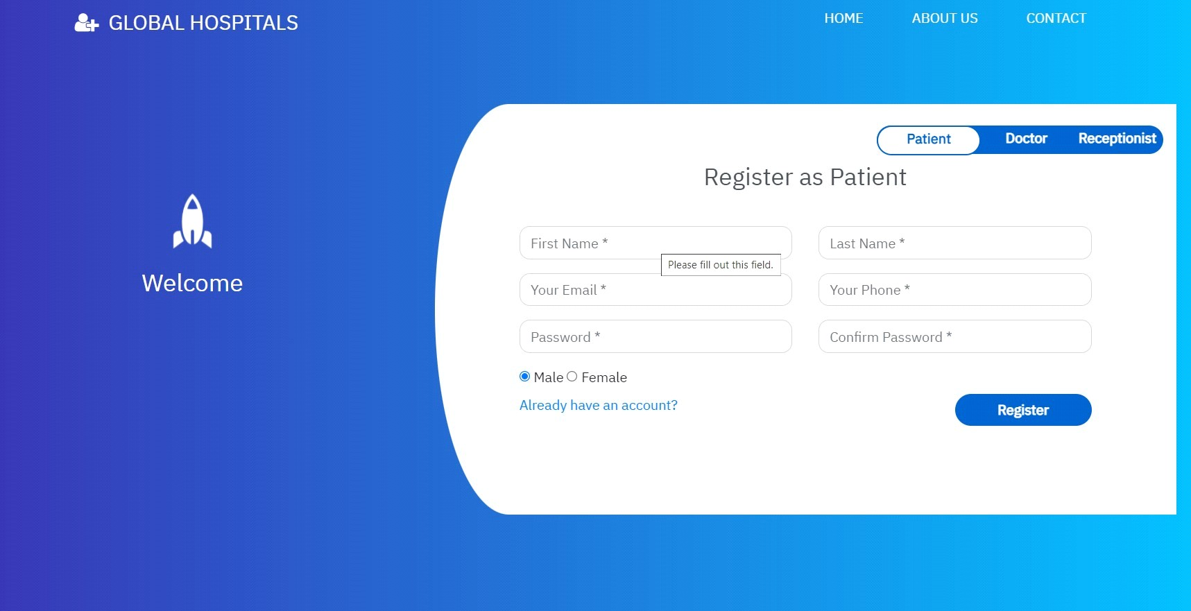

**Receptionist Logged in:**

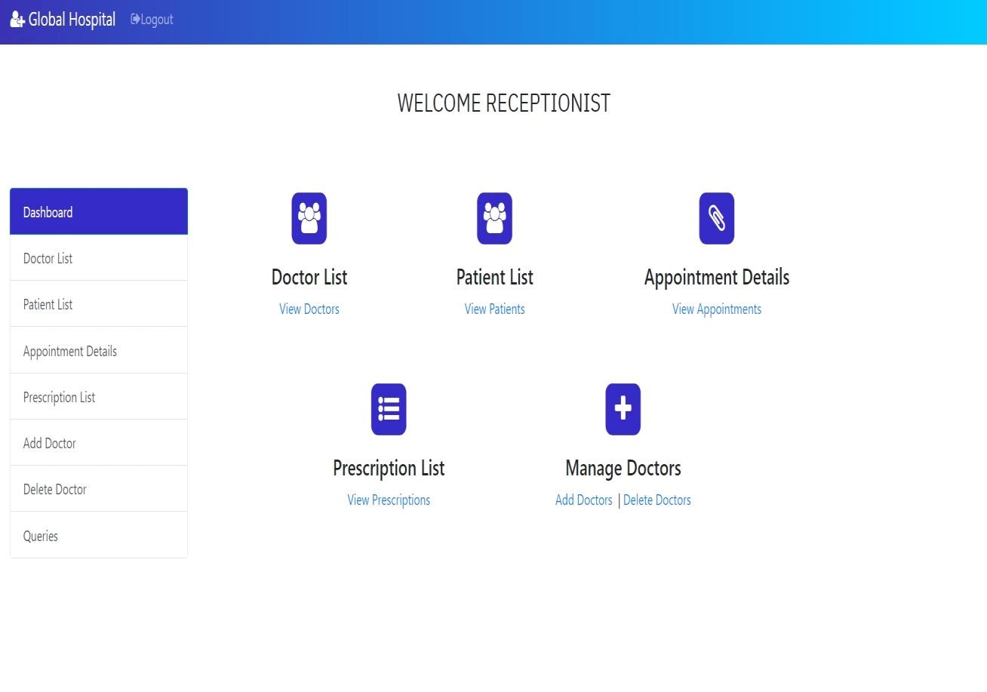

**Doctor Logged In**

**Services page:**

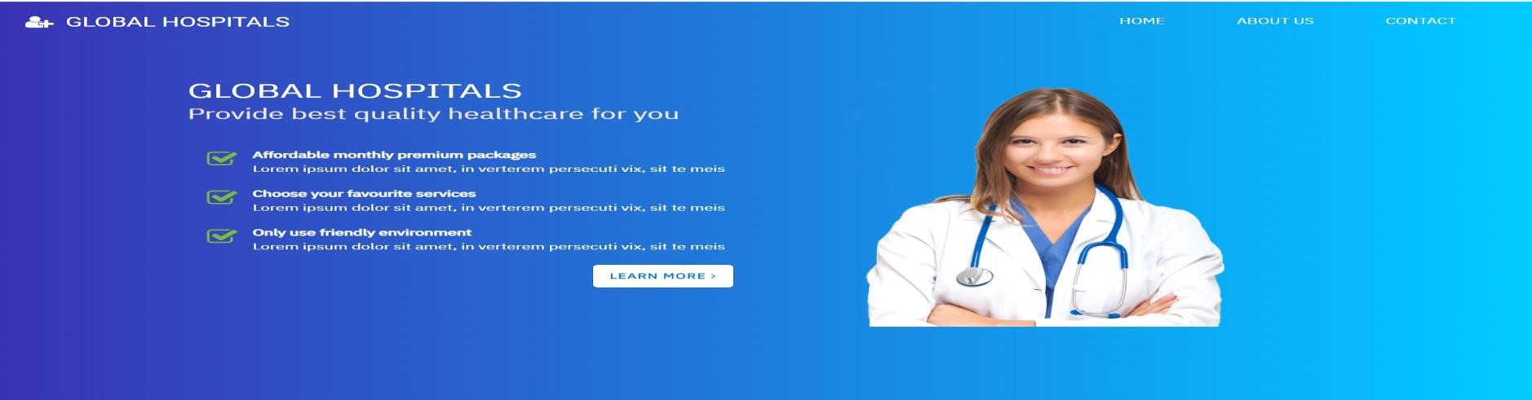

**Contact Page:**

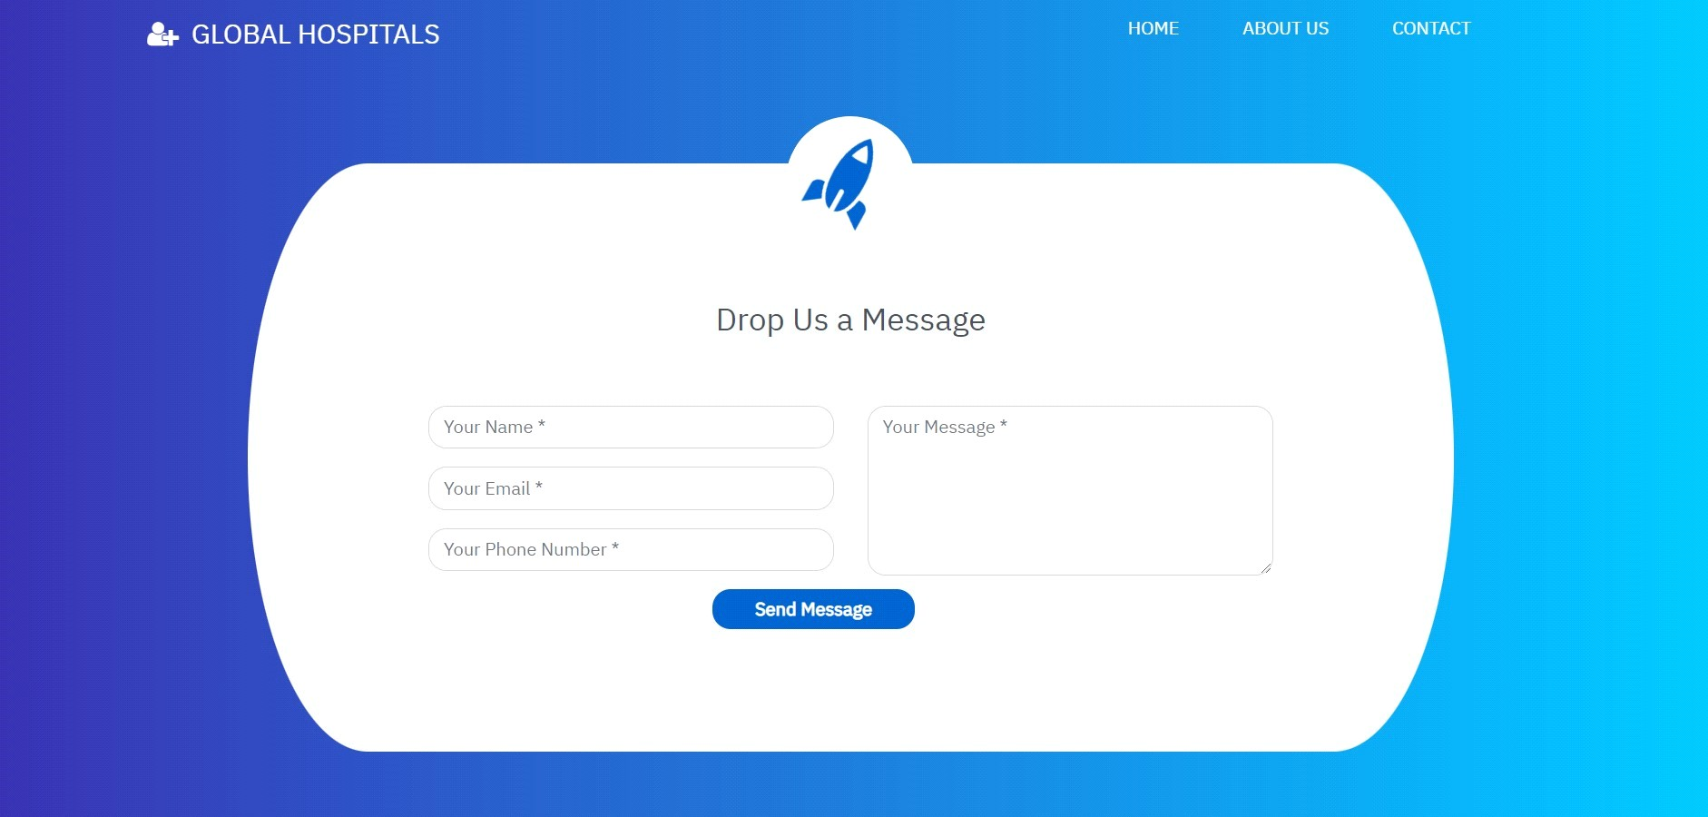

**Prescription List:**

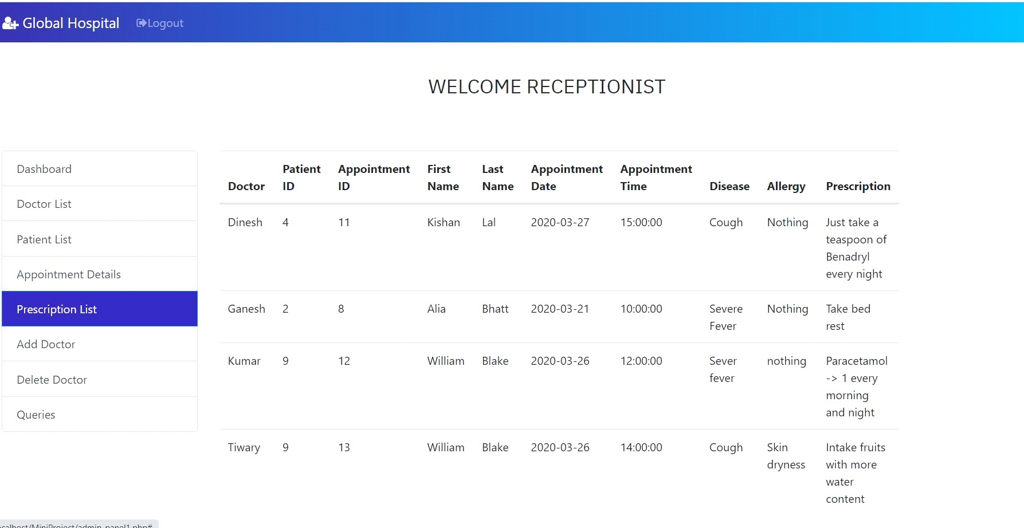

**Appointment Details:**

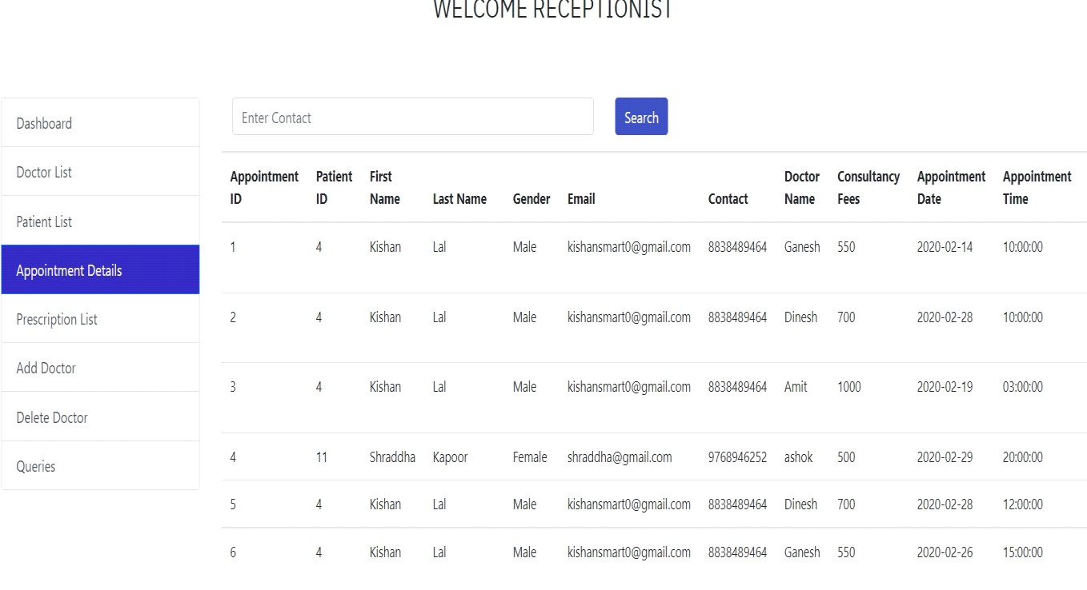

**Doctor List:**

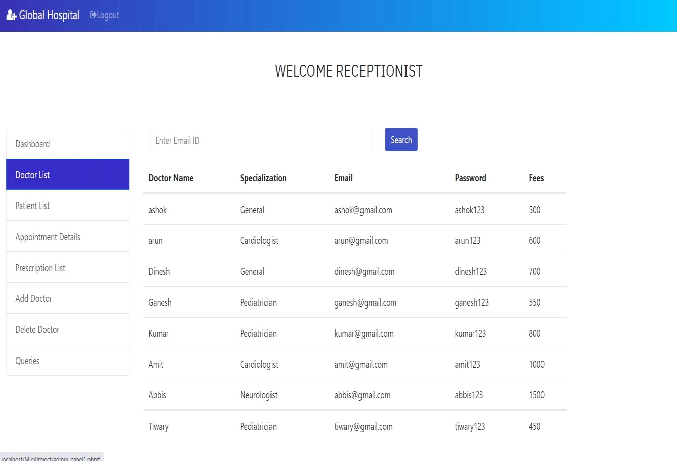

**Patient List:**

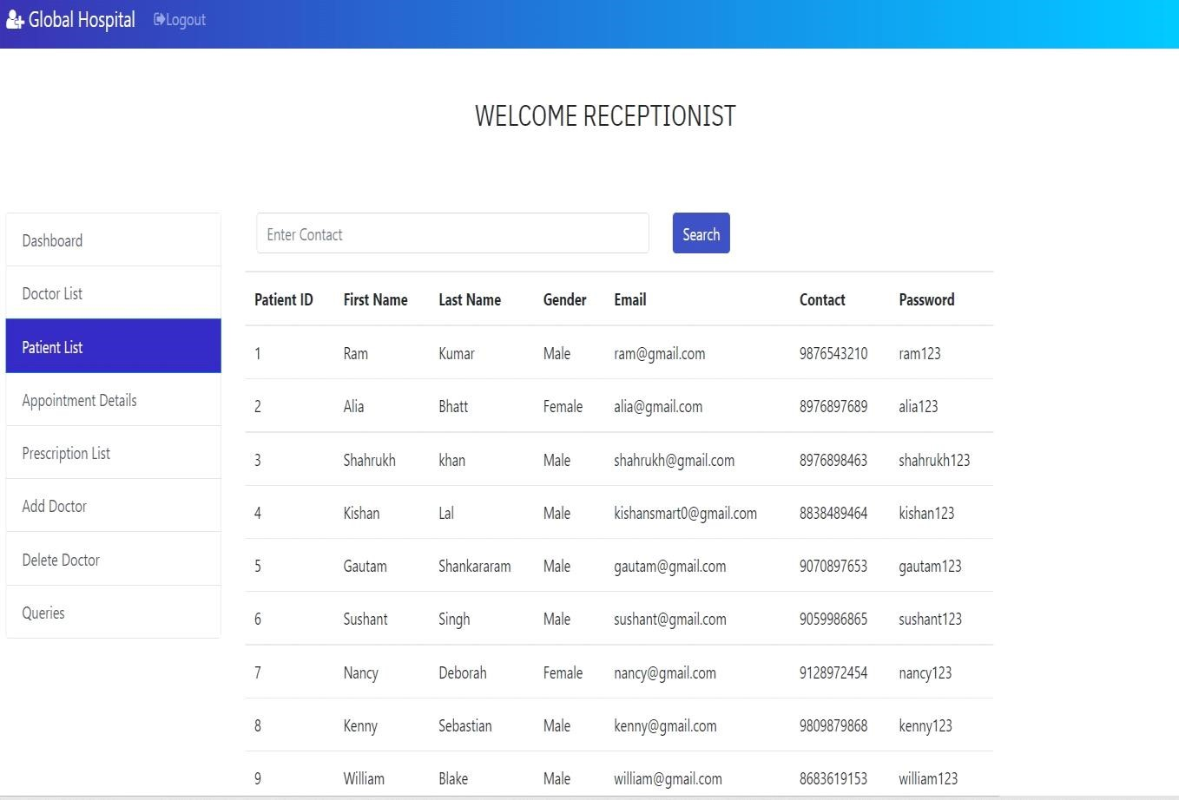

## CONCLUSION AND FUTURE SCOPE

**CONCLUSION:**

* **Global hospital data base helps in maintaining the records of the doctors, list of departments that it is containing, staff associated with it and the patients coming to the hospital, room details etc.**
* **This helps in reducing the effort in retrieving or searching for a particular information. This helps in increasing the efficiency in accessing the data in the hospital and helps in faster access to the information.**

EXISTING METHOD:

The information flow used is a one directional system where the receptionist refers patient to doctors, doctors referring patients to the pharmacist either in or out patients and the same way out. The system that is currently being used in the hospital is entirely manual. When a patient requests drugs from the staff, all the information is recorded manually from the drug dispenser (Pharmacist). Similarly when the supplier delivers drugs all the information from the dispenser to the account on drugs is recorded manually. The following are the weaknesses of the current system at the hospital:

1. The hospital staff finds it tiresome and time consuming when computing patient data, drug supplier and staff Payment receipts and voucher cards this leads to delay in medical reports.

1. The hospital Administration currently uses health record files for storing patients and drug supplier’s information. This system of information storage is susceptible to security problems such as illegal modification and update of records.

1. The Staff usually waste a lot of time in retrieving data.

1. The paper work reduce the efficiency of the System.

PROPOSED METHOD:

The proposed system is divided into Receptionist’s module, Doctor’s module and Patient’s module. Future Scope :

* + **This project will enhance the patients and the hospital to serve more quickly and efficiently. A hospital management system is developed in order to computerize the activities which take more time if done manually.**
  + **The hospital management system will enable the patient and hospital staff to make things faster and can get information quickly. If we want any information about the patient, we can access it quickly.**

### REFERENCES

* Shivkumar, S. and G. Umamaheswari. Performance Comparison of Advanced Encryption Standard (AES) and AES key dependent S-box-Simulation using MATLAB. in Process Automation, Control and Computing (PACC), 2011 International Conference on. 2011. IEEE.
* Alabaichi, A. and A.I. Salih. Enhance security of advance encryption standard algorithm based on key-dependent S-box. in Digital Information Processing and Communications (ICDIPC), 2015 Fifth International Conference on. 2015. IEEE.